CSE486L (Sec-1)

Lab 6 Codelab

Name:Leyon Ibn Kamal

ID: 1811050042

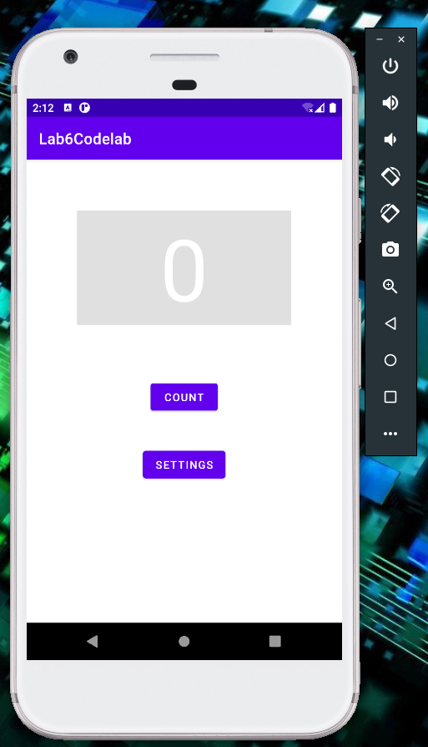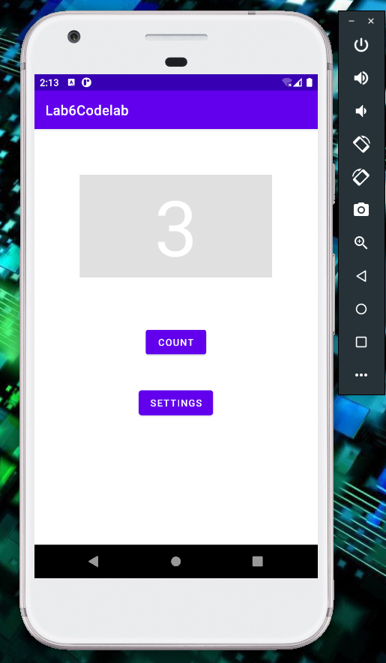Count

G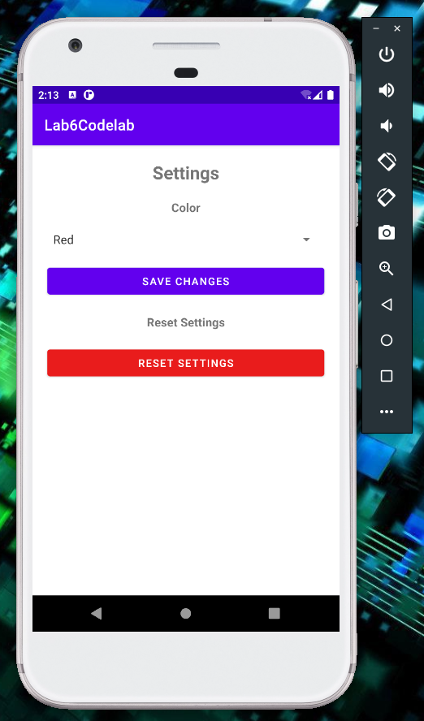o to settings and change background color and click save to store data in shared preferences.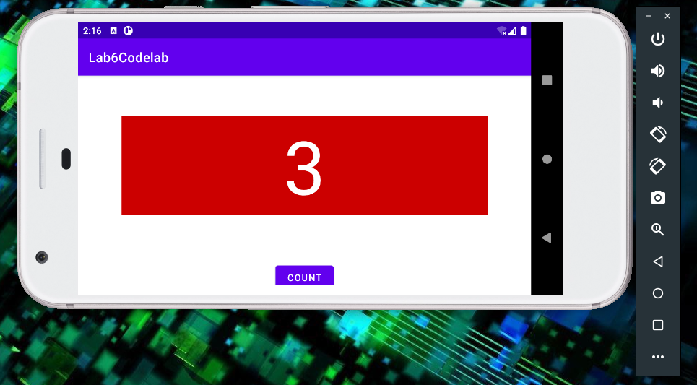 Data also persist when phone rotates. When coming back from settings activity data is reloaded as it is loaded from shared preferences using onResume() toget new settings.

Clicking reset button in settings resets the sharedpreference data.